2018 Community Health Assessment Proposal
Project Goals:
- Regional Community Health Assessment completed with uniform methodology across 31 counties to produce high-quality results.
- Satisfy IRS CHA requirements for area hospitals
- Satisfy CHA requirements for Public Health Accreditation Board for the health departments
- Satisfy CHA requirements for the Northern Michigan Community Health Innovation Region
Organization:
- Partners: Hospitals, Health Departments, and Tribes within Alliance regions are invited (see below)
- Committee made up of representatives from each partnering health department, hospital, and tribe
  - Each partner gets 1 seat (vote) on the CHA Steering Committee
    - The CHA Steering Committee roster will identify roles and responsibilities of each member
  - A smaller Design Team will make formal recommendations to the CHA Steering Committee
  - First CHA Strategy Design Team meeting is in February 2018 and the first CHA Steering Committee meeting will be in March/April 2018
- When the strategy and design are finalized, the CHA Steering Committee will decide which agencies are responsible for each step of the CHA methodology
- Proposed: Health Department of Northwest Michigan to act as project manager/fiduciary
  - Proposed: agreements would be in place with Northern Michigan Public Health Alliance partners that describes participation by all local health departments in the regional CHA and CHIP
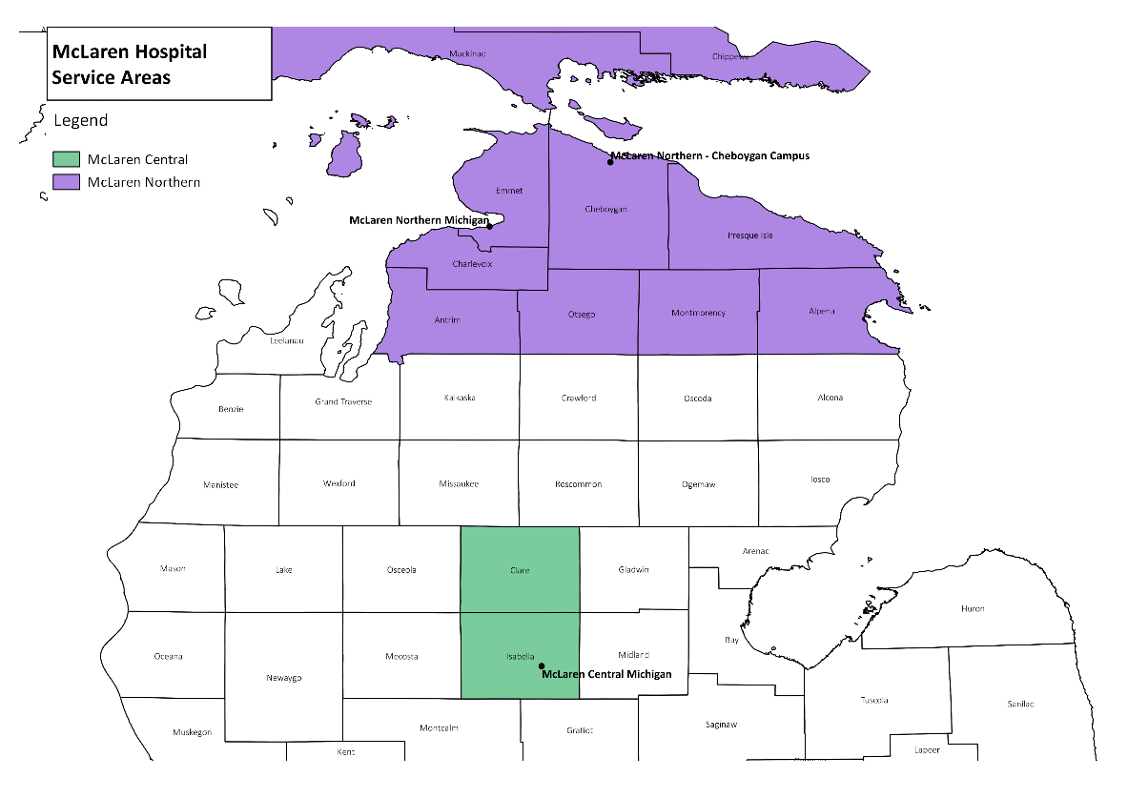
Partners:
McLaren Health Care
McLaren Northern Michigan (2015) - Partner
McLaren Central Michigan (2016) – Potential Partner

Munson Healthcare (2015) - Partner
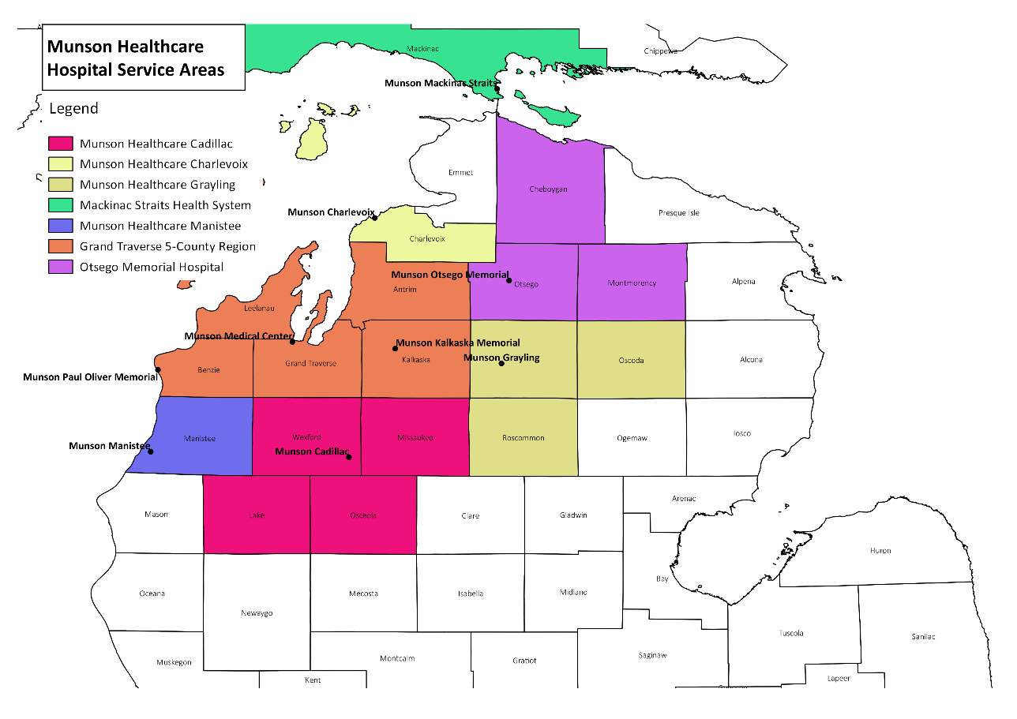
Munson Medical Center
Paul Oliver Memorial Hospital
Kalkaska Memorial Hospital (affiliated)
Otsego Memorial Hospital
Munson Healthcare Charlevoix
Mackinac Straits Health System (affiliated)
Munson Healthcare Cadillac
Munson Healthcare Grayling
Munson Healthcare Manistee
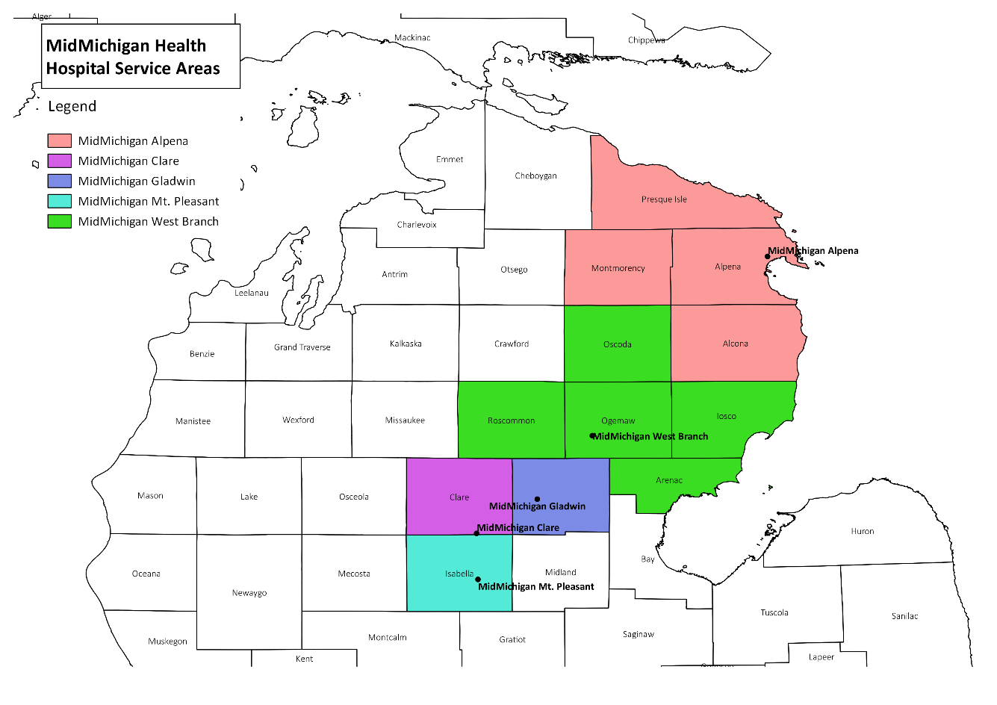
MidMichigan Health – Potential Partner
MidMichigan Medical Center-Alpena (2017-2018)
MidMichigan Medical Center-Clare (2016)
MidMichigan Medical Center-Gladwin (2016)
MidMichigan Medical Center-Mt. Pleasant (2017-2018)
MidMichigan Health Park-West Branch (2016)

St. Joseph Health System
St. Joseph Health System—Tawas (2016) – Potential Partner
Spectrum – Invited, but Unlikely Partner
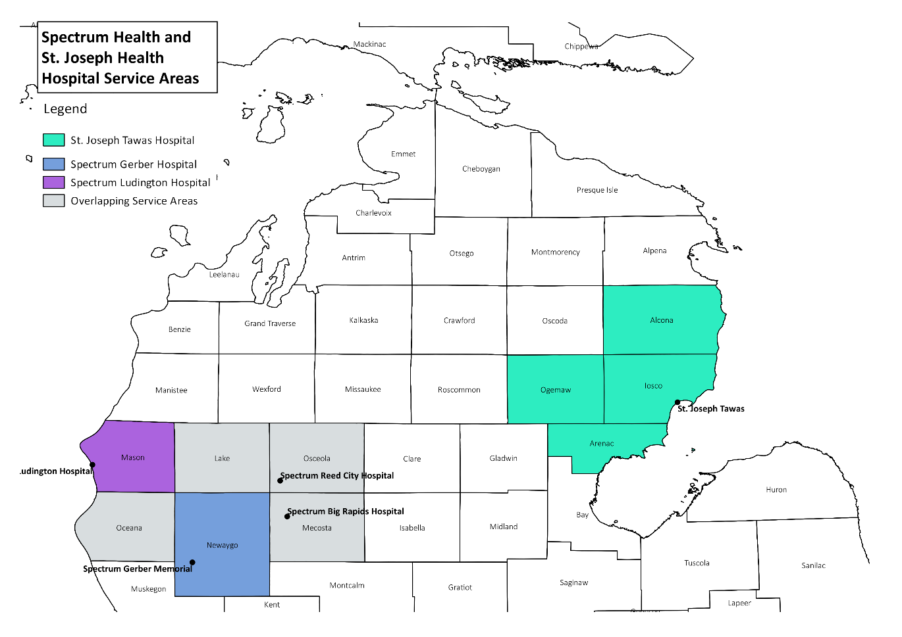
Gerber Memorial (2014-2015)
Big Rapids Hospital (2014-2015)
Ludington Hospital (2014-2015)
Reed City Hospital (2014-2015)

Health Departments: Northern Michigan Public Health Alliance - Partners
- Health Department of Northwest Michigan (HDNW)
- Grand Traverse County Health Department
- Benzie-Leelanau Health Department
- District Health Department #10
- District Health Department #4
- District Health Department #2
- Central Michigan Health Department
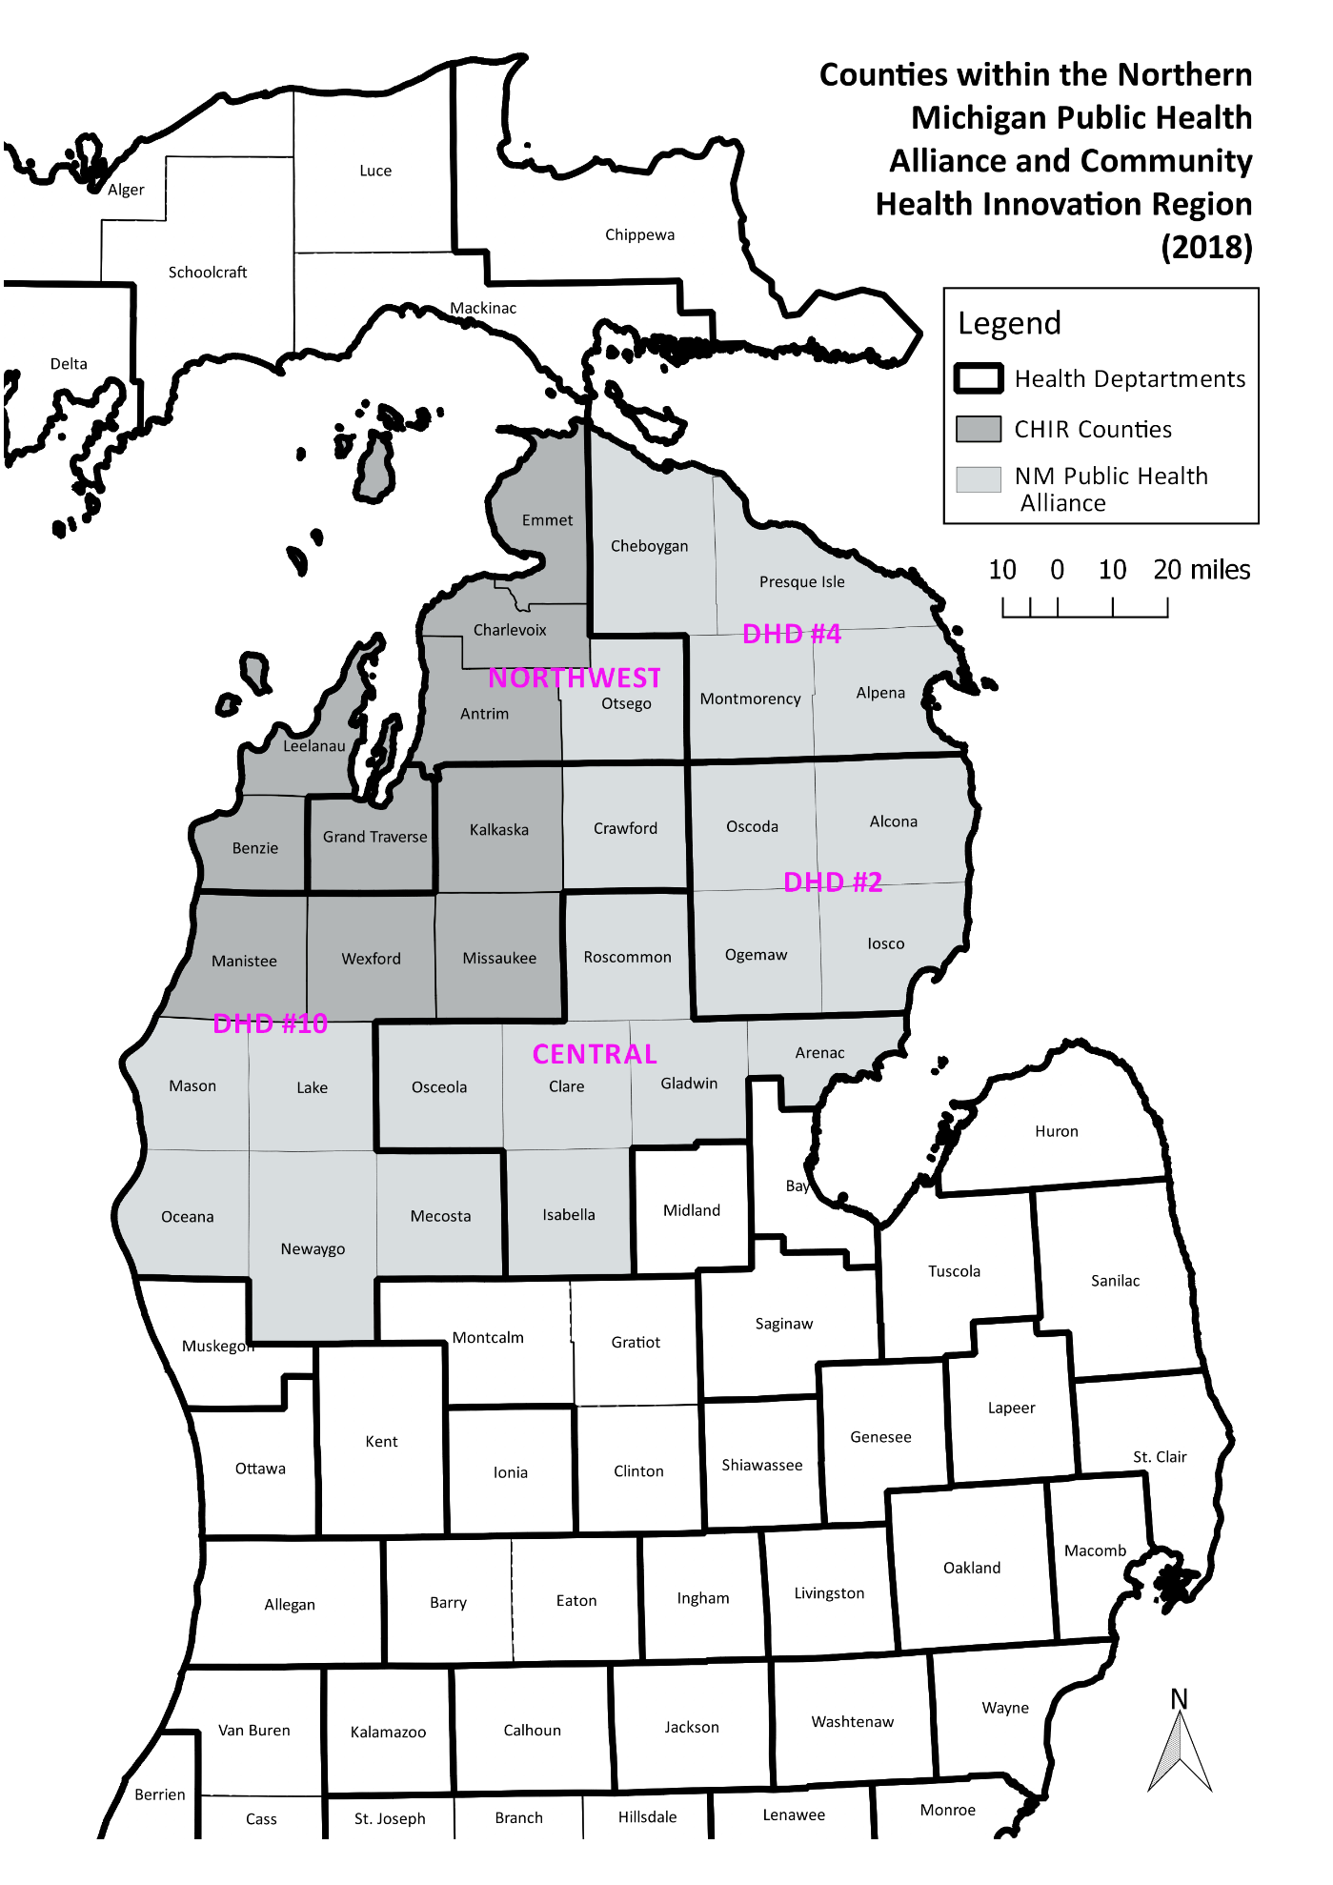
Tribes within Alliance region are invited to participate as well
- Little Traverse Bay Bands of Odawa Indians
- Grand Traverse Bay Band of Ottawa and Chippewa Indians
- Little River Band of Ottawa Indians
- Saginaw Chippewa Indian Tribe
Deadlines:
- Munson Medical Center CHA due June 2019; CHIP due November 2019
- McLaren Northern Michigan CHA due September 2019; CHIP due February 2020
- McLaren Central Michigan CHA due October 2019; CHIP due March 2020
- Our process will fall within Munson’s timeline, which should have McLaren ready early.
Funding:
- Not yet established. Tentatively, we are looking at funds from:
  - Munson Healthcare
  - Northern Health Plan
  - TenCon Health Plan
  - McLaren Health Care
  - MidMichigan Health
  - Community Health Innovation Region
  - Medicaid match dollars through the health departments
Methodology:
- Will use Mobilizing for Action through Planning and Partnerships (MAPP) framework, recommended by the National Association of County and City Health Officials
  - Includes assessments of Community Themes & Strengths; Local Public Health System; Community Health Status; Forces of Change
- For hospitals to comply with IRS requirements, the CHA must:
  - Define the community it services (and describe how this determination was made)
  - “Solicit and take into account input received from persons who represent the broad interests of the community” (IRS). At a minimum, this must include input received from:
    - At least one state, local, tribal, or regional governmental public health department, or a State Office of Rural Health
    - Members of the medically underserved, low-income, and minority populations in the community or individuals or organizations serving or representing the interests of such populations
    - Written comments received on the hospital’s most recently conducted CHA and most recently adopted implementation strategy
  - Identify the significant health needs of its community
    - “Health needs” can include the need to address financial and other barriers to care, as well as the need to prevent illness, to ensure adequate nutrition, or to address social, behavioral, and environmental factors that influence health in the community.
  - Prioritize those health needs (using any criteria, but community input must be taken into account, and these criteria and the prioritization process must be clearly defined in the report)
  - Identify potential resources in the community (including from the hospital) available to address the health needs
    - Hospitals should get community input on potentially available resources during CHA process
  - Publish a CHA report that is widely available to the public
    - A draft version may be made available for public comment before the report is finalized
    - Hospitals with different but overlapping communities may collaborate in conducting a CHA and may include substantively identical portions in their separate CHA reports if appropriate
- For the health departments to get accredited, the CHA must include both primary and secondary data, and both quantitative and qualitative data.
- Secondary data: HDNW will collect from other sources, like Behavioral Risk Factor Survey and the Michigan Profile for Health Youth. A poll will go out to partners regarding which indicators we are going to collect data for or the Steering Committee will decide
  - We will collect secondary for eastern UP counties falling within Munson or McLaren service areas
  - Can collect trend data going back several years for certain indicators if needed
  - Areas of secondary data enhancement needing further discussion:
    - Substance use and abuse
    - Environmental health
    - Immunizations
    - Utilizing age-adjusted mortality rates
    - Aggregate patient data from health departments and hospitals
    - Munson Medical Center diabetes survey
    - The NMPHA’s maternal and child health project
    - ABLe project on obesity
- Possible quantitative data: community survey; provider survey
  - Excellent opportunity to work with Academic partner to ensure high quality survey & data
- Possible qualitative data: Community question boards; CHAT games in each county; focus groups with cross-sector community leaders
Community Health Innovation Region (CHIR):
- May invite additional partners within the CHIR region who also have requirements for a community health assessment (like Community Mental Health or United Way), and factor in their needs
Other Ideas:
- Big kick-off event to gather stakeholders, current partners, and potential future partners
  - Could host a meeting in May after two Regional CHA Steering Committee meetings in March and April
- At the end, could create a region-wide vision or top long-term priorities, and establish metrics for tracking long range health indicators. This would complement the prioritization and CHIP creation in smaller areas, which focus on shorter term goals.

